Software Engineering-2

Logistics Dashboard

Index:

1. Use-Case Diagram ………………………………………………………………………………… 3
2. Activity Diagram ………………………………………………………………………………….. 4
3. Sequence Diagram ……………………………………………………………………………….. 12
4. Class Diagram ……………………………………………………………………………………….. 15
5. OCL ………………………………………………………………………………………………………. 16
6. ERD ……………………………………………………………………………………………………….. 20

Use Case

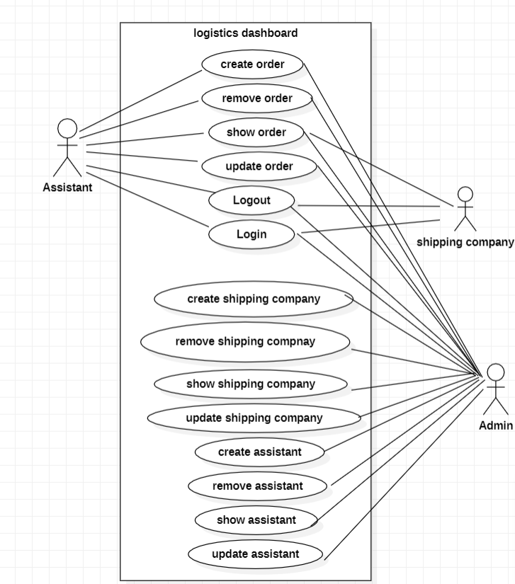

Activity

1. Login

1. Add order

1. Add Assistants/shipping company

1. Delete Assistants/ shipping company

1. Update Orders

1. Shipping Order State

1. Update Shipping company/ Order

1. Update assistant

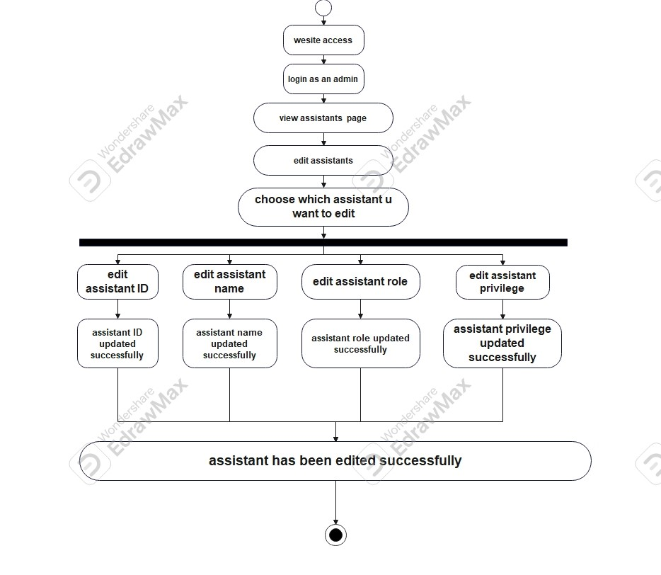

Sequence

1. Login

1. Add Assistants

1. Update Assistants

1. Delete Assistants

1. Add Shipping Company

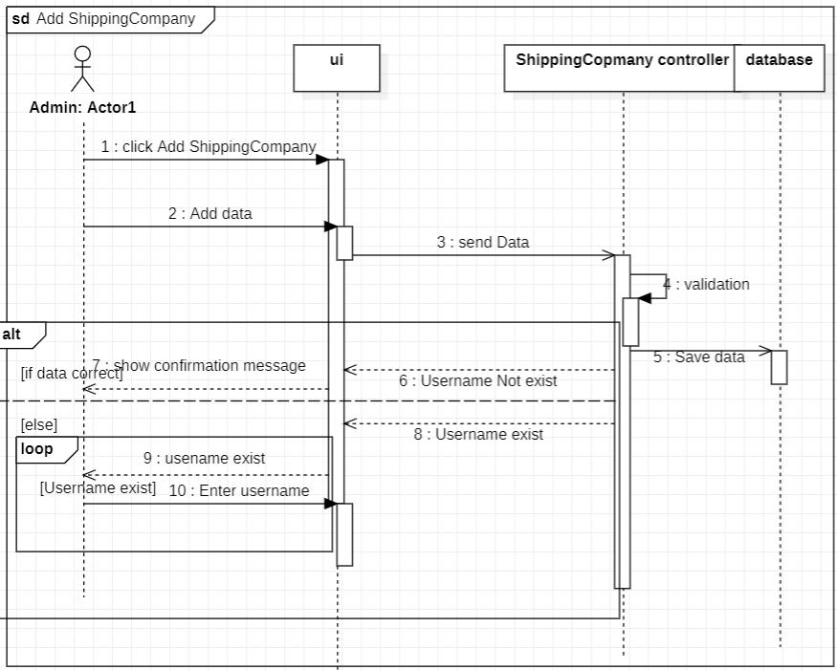

1. Delete Shipping Company

1. Update Shipping Company

1. Create Order

Class

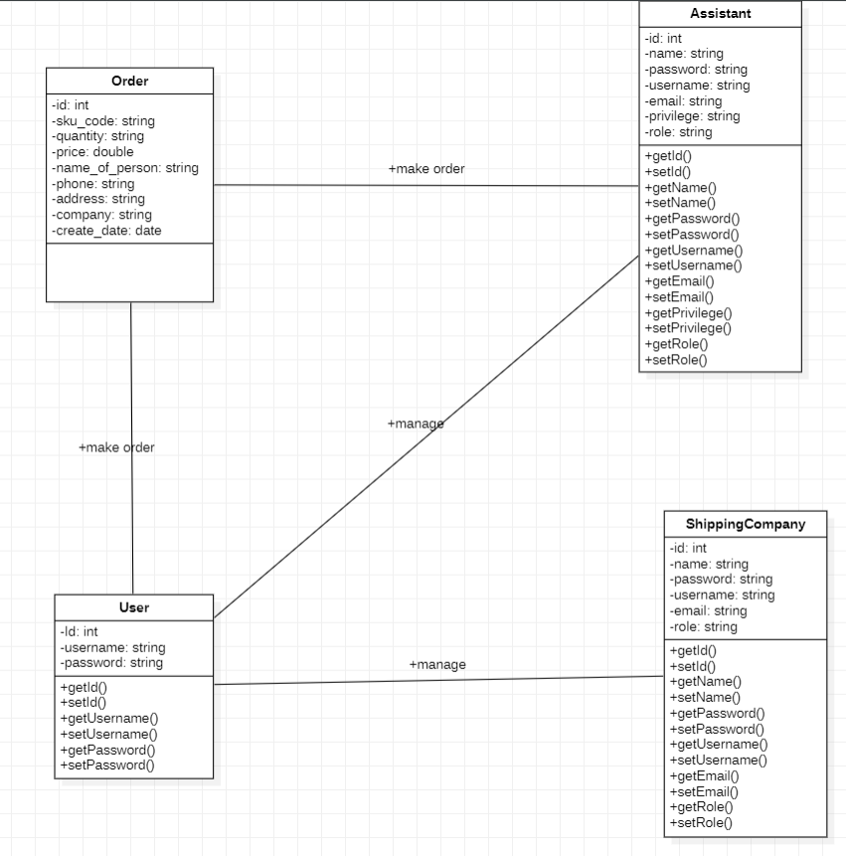

OCL

1. User

Username should not be null or empty

context User

inv UsernameNotEmpty: username <> null and not username.isEmpty()

Password should not be null or empty

inv PasswordNotEmpty: password <> null and not password.isEmpty()

1. Assistant

Each Assistant must have a unique identifier

context Assistant

inv UniqueId: Assistant.allInstances()->isUnique(id)

Name should not be null or empty

inv NameNotEmpty: name <> null and not name.isEmpty()

Password should not be null or empty

inv PasswordNotEmpty: password <> null and not password.isEmpty()

Username should not be null or empty

inv UsernameNotEmpty: username <> null and not username.isEmpty()

Email should not be null or empty

inv EmailNotEmpty: email <> null and not email.isEmpty()

Privilege should not be null or empty

inv PrivilegeNotEmpty: privilege <> null and not privilege.isEmpty()

Role should not be null or empty

inv RoleNotEmpty: Role <> null and not Role.isEmpty()

1. Company

Ensures each shipping company has a unique identifier

context ShippingCompany

inv UniqueId: ShippingCompany.allInstances()->isUnique(id)

Ensures the name attribute is not null or empty

inv NameNotEmpty: name <> null and not name.isEmpty()

Ensures the password attribute is not null or empty

inv PasswordNotEmpty: password <> null and not password.isEmpty()

Ensures the username attribute is not null or empty

inv UsernameNotEmpty: username <> null and not username.isEmpty()

Ensures the email attribute is not null or empty

inv EmailNotEmpty: email <> null and not email.isEmpty()

Ensures the Role attribute is not null or empty

inv RoleNotEmpty: Role <> null and not Role.isEmpty()

Define Admin Capabilities:

context User

inv: self.type = 'admin' implies self.canAddAssistants and self.canAddShippingCompanies and self.canAddOrders

Define Assistant Capabilities:

context User

inv: self.type = 'assistant' implies not self.canAddAssistants and not self.canAddShippingCompanies and self.canAddOrders

Define Shipping Company Capabilities:

context User

inv: self.type = 'shipping_company' implies not self.canAddAssistants and not self.canAddShippingCompanies and not self.canAddOrders

Define Login Validation

context User

inv: self.checkCredentials(username, password) implies self.existsInDatabase(username, password)

Define Admin's Ability to Add Users:

context Admin

inv: self.addUser(user) implies (user.type = 'assistant' or user.type = 'shipping_company')

Define Shipping Company's Ability to View Orders:

context ShippingCompany

inv: self.viewOrders() implies self.canViewOrders

Admin Role Preconditions for Adding Users:

context Admin::addUser(user)

pre: self.type = 'admin' and (user.type = 'assistant' or user.type = 'shipping_company')

ERD

